Practicum No.3 Date:……….

Address calculation using addressing modes

- Practical Significance

Effective Address (EA) calculation is a fundamental building block in computer architecture, instruction execution, memory access and compiler design. Addressing modes help processors access memory efficiently during instruction execution. They eliminate redundant instructions, reduce program size, accelerate array/pointer operations, and simplify loop processing. MATLAB simulation enables students to visualize and calculate effective addresses for multiple addressing modes including:
- Direct addressing
- Indirect addressing
- Indexed addressing
- Base + Index
- Base + Index + Displacement
- Scaled Index addressing
- Stack addressing
- PC-relative addressing

- Competency and Industry-Specific Practical Skills

Use the principles of computer architecture to optimize system performance
- Select appropriate addressing mode for a specific memory operation (PDO)
- Translate an instruction into its effective address (CDO)
- Use MATLAB to validate address calculations systematically (PDO)

- Relevant CO(s) (As stated in the Course Structure)

- CO1. Use the relevant instruction cycle to efficiently manage the processor's functionality.

- Practical Outcome (PrO) (As stated in the Course Structure)

- Develop programs to do address calculation for the given addressing modes.

- Related ADO(s) (As stated in the Course Structure)

- Follow ethical practices in designing or evaluating the system design.
- Apply systematic design principles and debugging techniques.
- Function effectively as a team member.

- Minimum Underpinning Theory (Include relevant content & images for this practicum.)

An addressing mode defines how a processor locates data required by an instruction.
The Effective Address (EA) is the actual memory address from which data is fetched or stored.
Typical Addressing Modes & EA calculation rules:

Addressing Mode | EA Formula | Example
Immediate | Operand is part of instruction | MOV R1, #25
Direct | EA = Address | LOAD R1, 500
Indirect | EA = (Address) | LOAD R1, (500)
Register | Operand in register | ADD R1, R2
Register Indirect | EA = (Ri) | LOAD R1, (R2)
Indexed | EA = Base + Index | LOAD R1, A[Ri]
Displacement | EA = Base + Disp | LOAD R1, 100(R2)
Base + Index + Displacement | EA = Base + Index + Disp | A[R1 + R2 + 4]
Scaled Index | EA = Base + Index × Scale | Arrays, structures
PC-relative | EA = PC + Offset | Branch instructions
Stack addressing | EA = SP ± Offset | PUSH / POP
Figure 1: EA calculation block diagram

- Practicum Set-up/Circuit Diagram/Algorithm/Flowchart (Include probable photos of experimental set-up.)

Students must have:
- MATLAB installed
- Script file: exp3_addressing_modes.m
- Input dataset (base, index, displacement, PC, SP, scale)
- Example instruction formats
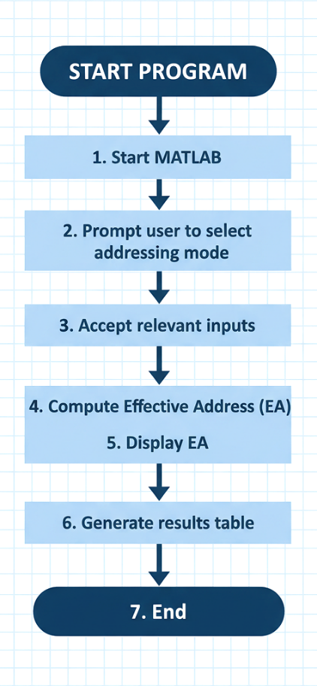

- Resources Required

S. No. | Resource | Suggested Broad Specification | Quantity
1 | MATLAB | (R2016b or newer) or GNU Octave (with mostly compatible syntax). | 1 No.
2 | PC | PC with MATLAB installed. | 1 No.
3 | Text editor / MATLAB Editor | - | 1 No.

- Safety Precautions

- Save work frequently.
- Comment code and include header describing author, date, input format and usage.
- For shared code, remove hard-coded absolute paths.
- Validate user inputs to avoid invalid logical values and runtime errors.

- Procedure (Self-Instructional)

- Display the list of supported addressing modes to the user.
- Select the addressing mode based on user input (Direct, Indirect, Indexed, Displacement, Scaled Index, PC-Relative, Stack).
- Accept the required input values such as Base, Index, Displacement, Scale factor, PC, or SP depending on the chosen mode.
- Validate the entered inputs for correct numeric format and applicable addressing mode requirements.
- Compute the Effective Address (EA) using the corresponding formula for the selected addressing mode along with memory access count, power consumption and time (Using tic, toc. tic and toc do not measure actual CPU execution time. They provide a relative software-level comparison that reflects the impact of memory access differences between addressing modes).
- Print the computed the addressing mode, computed Effective Address, memory access count, execution time, execution speed, and power consumption in the MATLAB command window.
- Repeat the calculation if the user selects another addressing mode.
- Terminate the program when the user chooses to exit.
Note: Instruction fetch is not considered while counting memory accesses; only operand access is considered. In indirect addressing, pointer dereferencing is assumed to focus on effective address computation.

clc;
clear;

choice = 1;

while choice ~= 0

% -------- Display Menu --------
disp('------------------------------------------');
disp('ADDRESSING MODES');
disp('1. Immediate Addressing');
disp('2. Register Addressing');
disp('3. Direct Addressing');
disp('4. Indirect Addressing');
disp('5. Indexed Addressing');
disp('6. Displacement Addressing');
disp('7. Base + Index + Displacement Addressing');
disp('8. Scaled Index Addressing');
disp('9. PC-Relative Addressing');
disp('10. Stack Addressing');
disp('0. Exit');
disp('------------------------------------------');

choice = input('Enter your choice: ');

if choice == 0
disp('Program terminated.');
break;
end

EA = 'Not Applicable';
mem_access = 0;
exec_time = 0;

switch choice

case 1 % Immediate Addressing
disp('Immediate Addressing Selected');
operand = input('Enter immediate operand value: ');

tic;
EA = 'Not Applicable';
mem_access = 0;
exec_time = toc;

case 2 % Register Addressing
disp('Register Addressing Selected');
regVal = input('Enter register value: ');

tic;
EA = 'Not Applicable';
mem_access = 0;
exec_time = toc;

case 3 % Direct Addressing
disp('Direct Addressing Selected');
addr = input('Enter memory address: ');

tic;
EA = addr;
mem_access = 1;
exec_time = toc;

case 4 % Indirect Addressing
disp('Indirect Addressing Selected');
ptr = input('Enter pointer value (address obtained from memory): ');

tic;
EA = ptr; % Pointer dereference assumed
mem_access = 2; % Fetch pointer + operand
exec_time = toc;

case 5 % Indexed Addressing
disp('Indexed Addressing Selected');
base = input('Enter Base address: ');
index = input('Enter Index value: ');

tic;
EA = base + index;
mem_access = 1;
exec_time = toc;

case 6 % Displacement Addressing
disp('Displacement Addressing Selected');
base = input('Enter Base address: ');
dispVal = input('Enter Displacement value: ');

tic;
EA = base + dispVal;
mem_access = 1;
exec_time = toc;

case 7 % Base + Index + Displacement
disp('Base + Index + Displacement Addressing Selected');
base = input('Enter Base address: ');
index = input('Enter Index value: ');
dispVal = input('Enter Displacement value: ');

tic;
EA = base + index + dispVal;
mem_access = 1;
exec_time = toc;

case 8 % Scaled Index Addressing
disp('Scaled Index Addressing Selected');
base = input('Enter Base address: ');
index = input('Enter Index value: ');
scale = input('Enter Scale factor: ');

tic;
EA = base + (index * scale);
mem_access = 1;
exec_time = toc;

case 9 % PC-Relative Addressing
disp('PC-Relative Addressing Selected');
PC = input('Enter Program Counter (PC) value: ');
offset = input('Enter Offset value: ');

tic;
EA = PC + offset;
mem_access = 1;
exec_time = toc;

case 10 % Stack Addressing
disp('Stack Addressing Selected');
SP = input('Enter Stack Pointer (SP) value: ');

tic;
EA = SP - 1; % Pre-decrement stack
mem_access = 1;
exec_time = toc;

otherwise
disp('Invalid choice. Please select a valid option.');
continue;
end

% -------- Performance Classification --------
if mem_access == 0
exec_speed = 'Fast';
power = 'Less';
elseif mem_access == 1
exec_speed = 'Moderate';
power = 'More';
else
exec_speed = 'Slow';
power = 'More';
end

% -------- Display Results --------
disp('------------------------------------------');
disp(['Effective Address (EA) : ', num2str(EA)]);
disp(['Memory Accesses : ', num2str(mem_access)]);
disp(['Execution Time (sec) : ', num2str(exec_time)]);
disp(['Execution Speed : ', exec_speed]);
disp(['Power Consumption : ', power]);
disp('------------------------------------------');

end

Sample Output Table:
Mode | Input | Computed Effective Address (EA)
Immediate | Operand = 25 | Not Applicable
Register | R1 = 500 | Not Applicable
Direct | Address = 1200 | 1200
Indirect | Pointer Value = 1500 | 1500
Indexed | Base = 1000, Index = 20 | 1020
Displacement | Base = 1000, Displacement = 24 | 1024
Base + Index + Displacement | Base = 1000, Index = 20, Disp = 4 | 1024
Scaled Index | Base = 2000, Index = 3, Scale = 4 | 2012
PC-Relative | PC = 5000, Offset = −10 | 4990
Stack | SP = 3000 | 2999

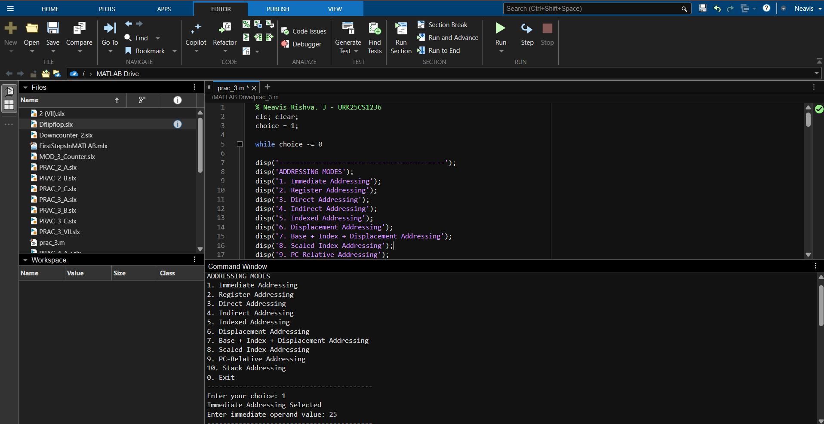
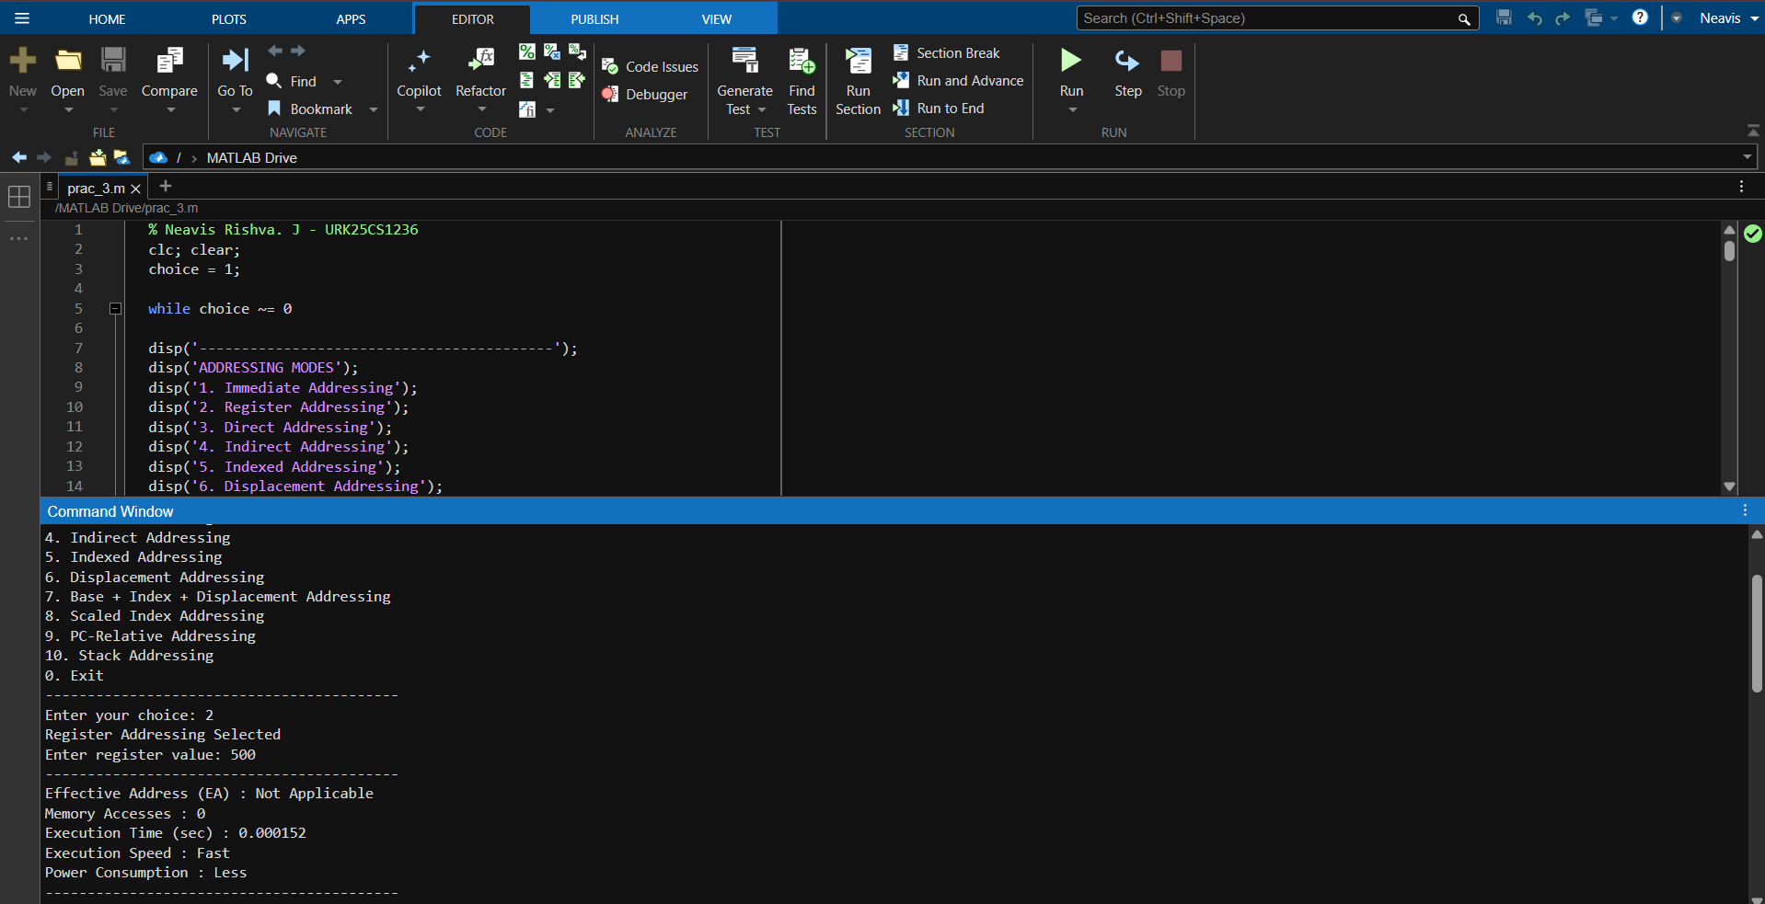
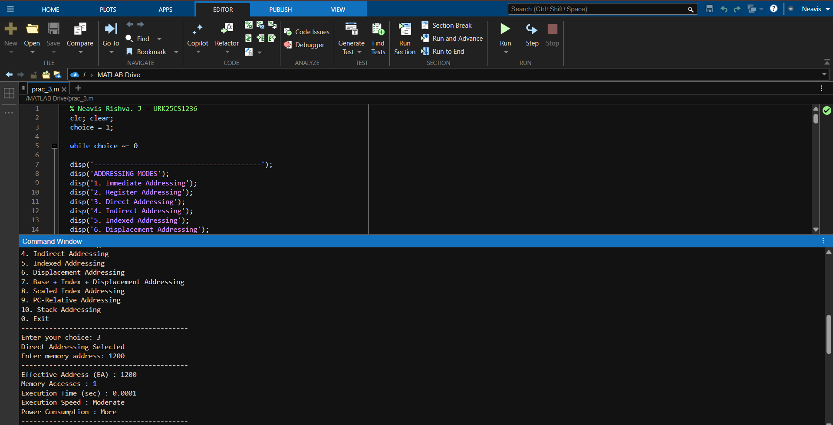
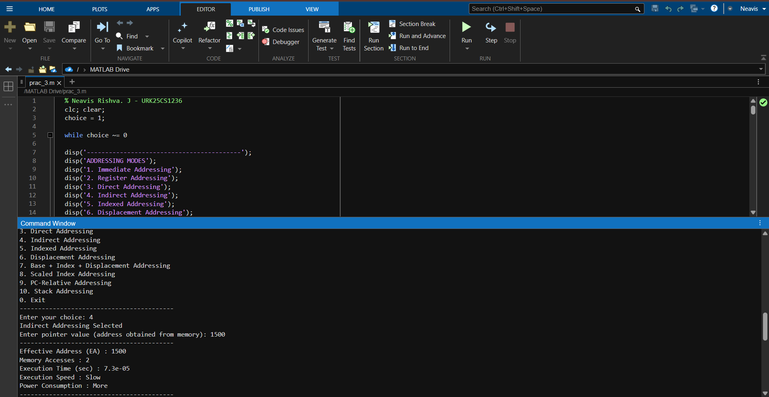
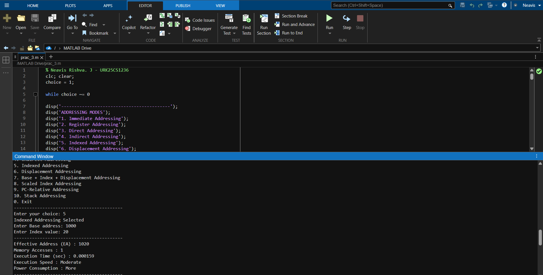
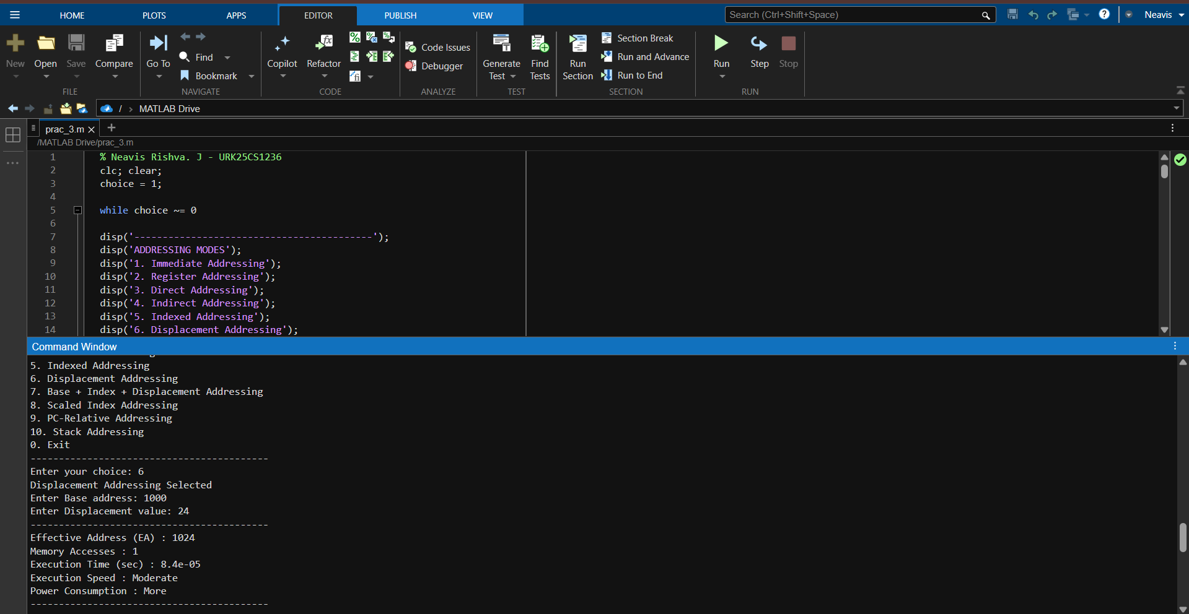
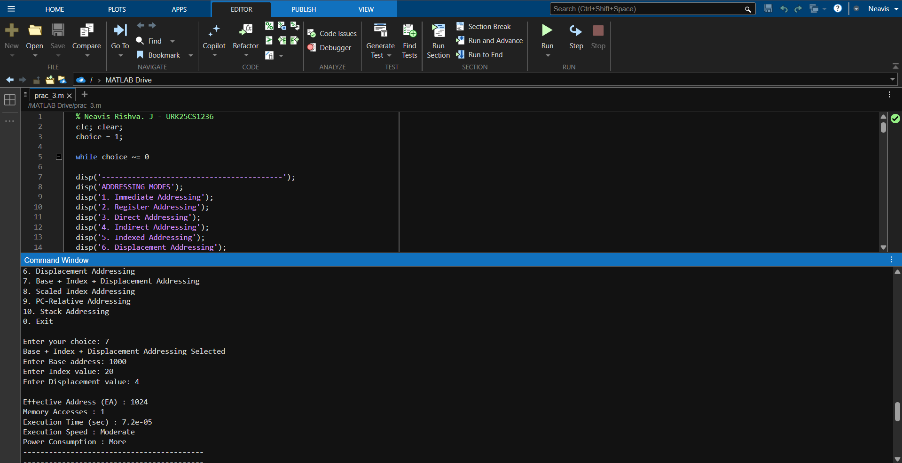
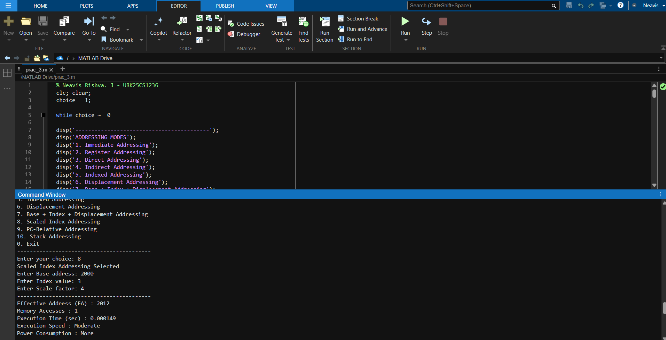
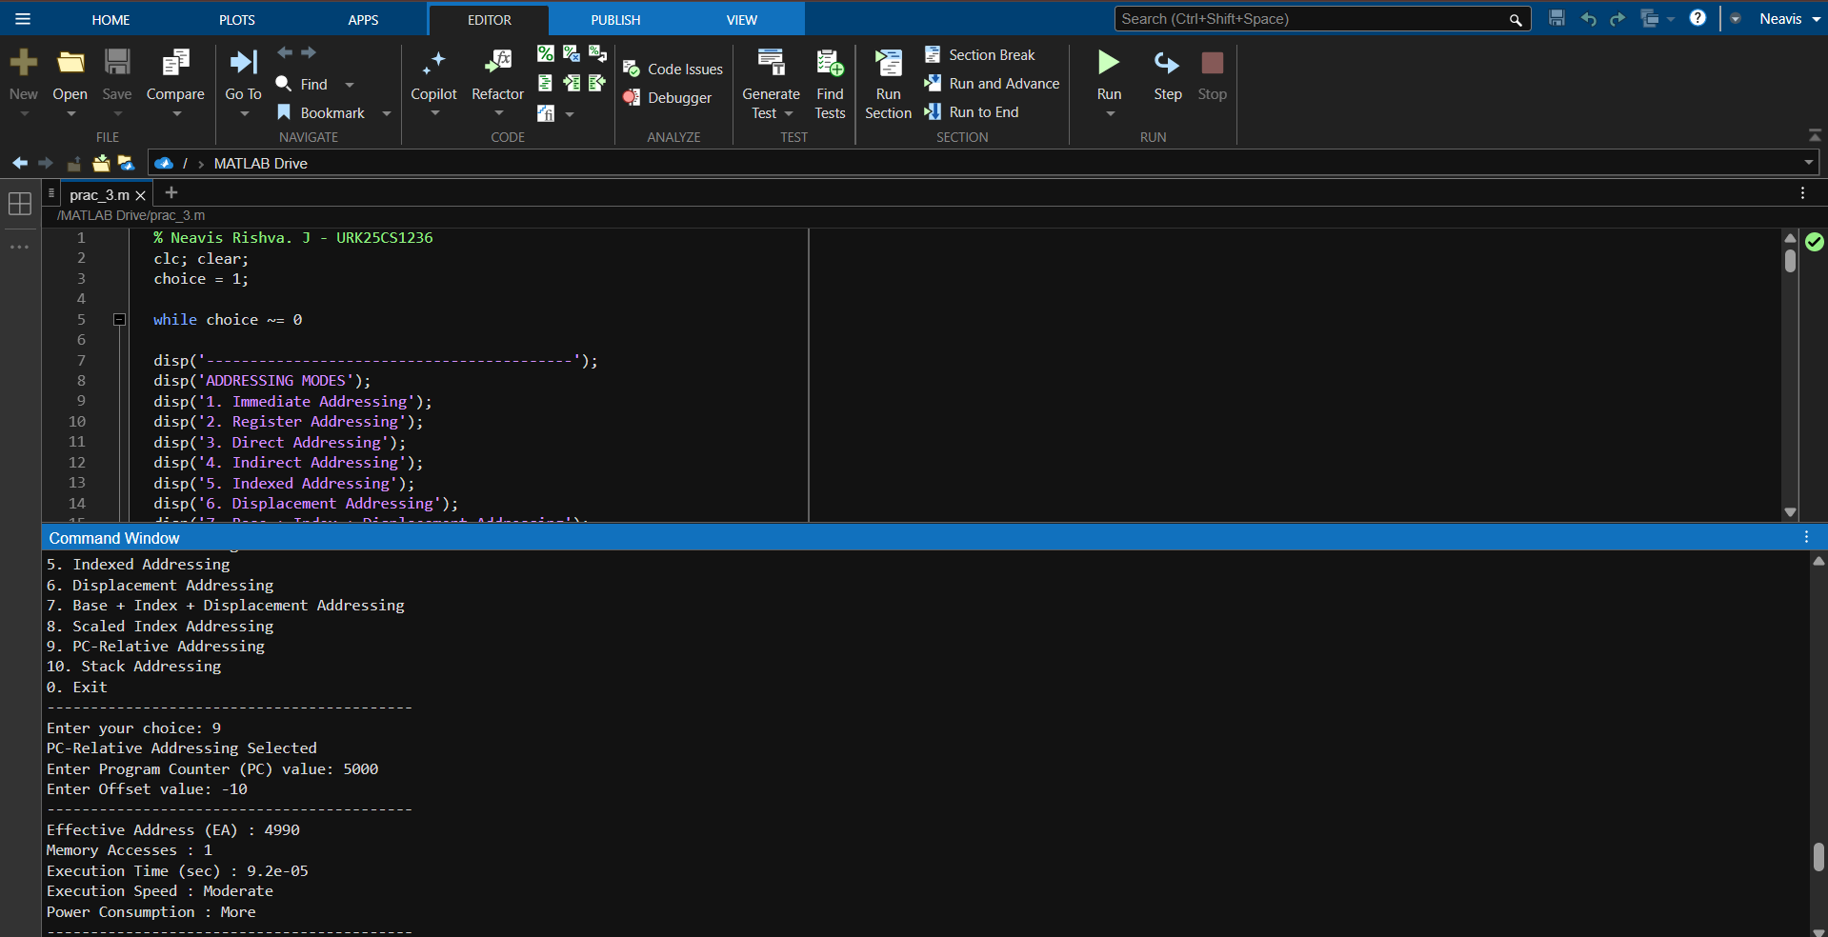
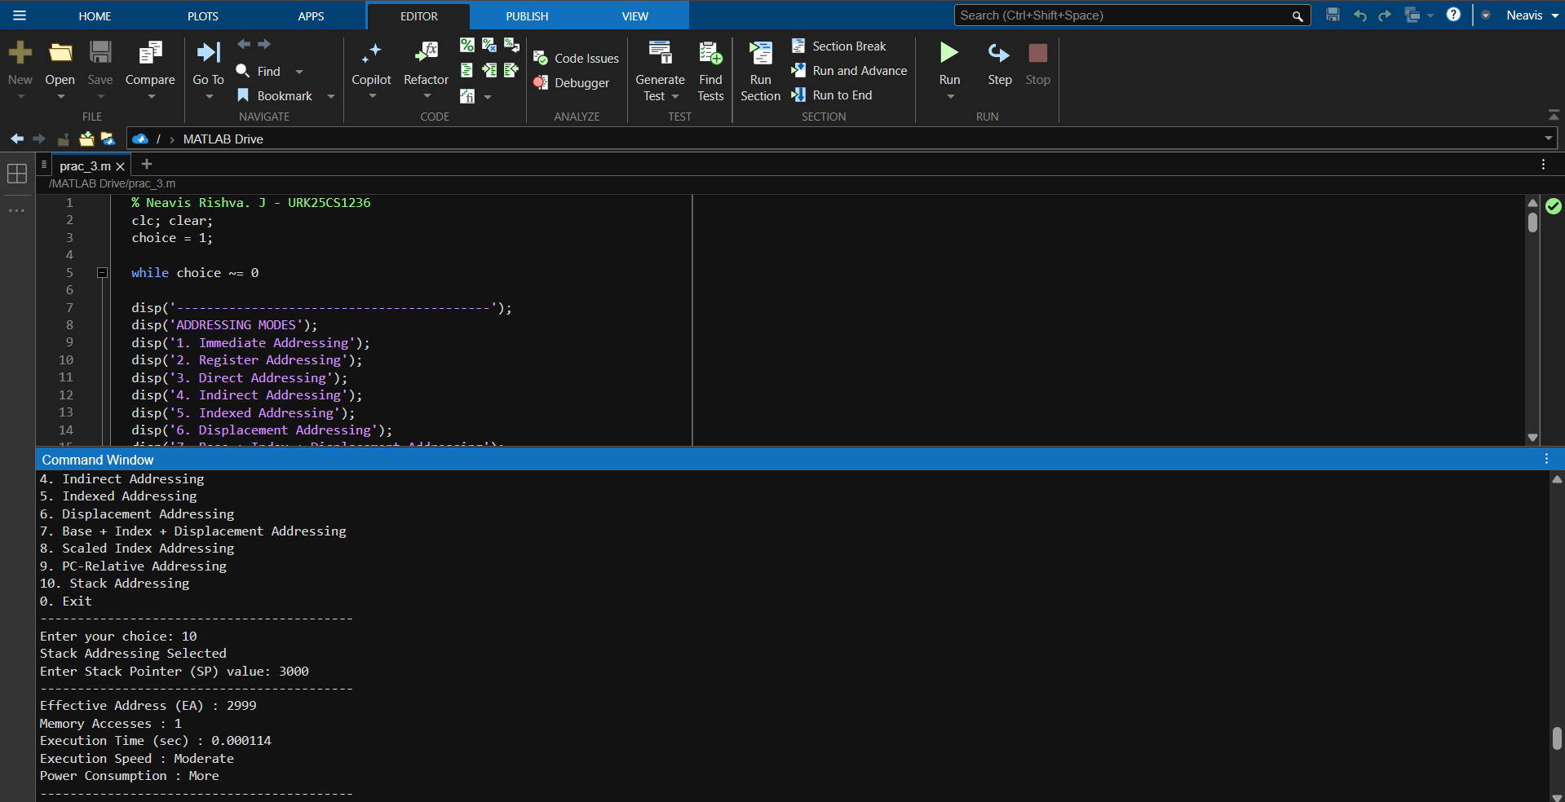

- Actual Resources Used (To be filled by the students)

S. No. | Name of Resource | Broad Specifications |  | Quantity | Remarks  (If any)
 |  | Make | Details
 | MATLAB | Version R2016b | 1 | - | MATLAB
 | Laptop | Intel i5 | 1 | - | Laptop
 | MATLAB Editor | N/A | 1 | - | MATLAB Editor

- Actual Procedure Followed (To be filled by the students)
- MATLAB software was opened on the PC and the script file for addressing mode calculation was created/loaded.
- The program was executed to display the menu of available addressing modes.
- An addressing mode was selected by entering the corresponding choice.
- Required input values such as Base address, Index value, Displacement, PC, SP, or Scale factor were entered according to the selected mode.
- The program computed the Effective Address (EA), number of memory accesses, execution time, execution speed, and power consumption.
- The output results displayed in the MATLAB command window were observed and recorded in the observation table.
- Steps 3–6 were repeated for different addressing modes to collect multiple test cases.
- After completing the required runs, the program was terminated.
- Additional Questions
- Execute the MATLAB program using Immediate addressing and Direct addressing for the same operand value and compare the number of memory accesses, execution time, and suitability for real-time systems.

CODE:

%Neavis Rishva.J - URK25CS1236

clc; clear;

operand = 500;
addr = 500;
disp('--- Immediate Addressing ---');
tic;
EA_imm = 'Not Applicable';
mem_access_imm = 0;
time_imm = toc;

disp('--- Direct Addressing ---');
tic;
EA_dir = addr;
mem_access_dir = 1;
time_dir = toc;

fprintf('\nComparison:\n');
fprintf('Immediate Addressing -> Memory Accesses: %d | Time: %.6f sec\n', mem_access_imm, time_imm);
fprintf('Direct Addressing -> Memory Accesses: %d | Time: %.6f sec\n', mem_access_dir, time_dir);

if mem_access_imm < mem_access_dir
disp('Immediate addressing is faster and more suitable for real-time systems.');
end
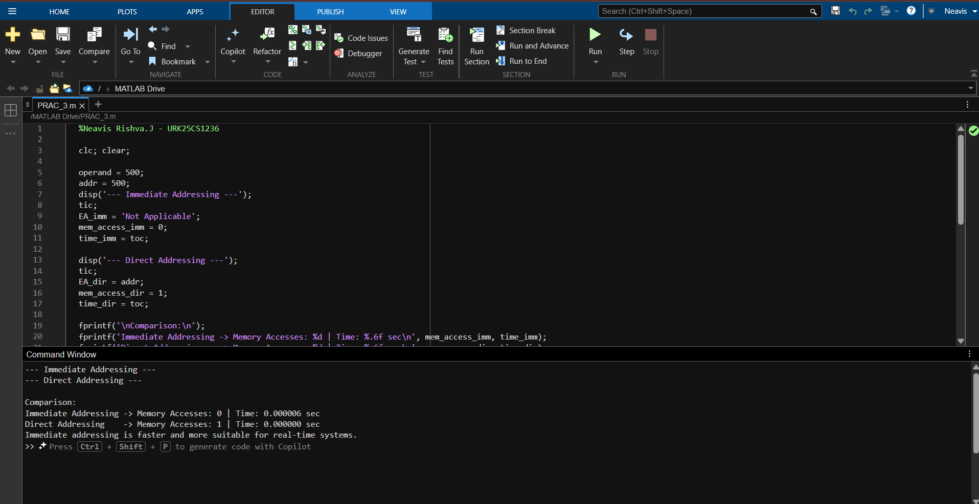

- Run the MATLAB program using Register addressing and Register Indirect addressing with the same register value and analyze the difference in memory access count and execution time.

CODE:

%Neavis Rishva. J – URK25CS1236

clc; clear;

regVal = 1000;

disp('--- Register Addressing ---');
tic;
EA_reg = 'Not Applicable';
mem_access_reg = 0;
time_reg = toc;

disp('--- Register Indirect Addressing ---');
tic;
EA_reg_ind = regVal;
mem_access_reg_ind = 1;
time_reg_ind = toc;

fprintf('\nComparison:\n');
fprintf('Register Addressing -> Memory Accesses: %d | Time: %.6f sec\n', mem_access_reg, time_reg);
fprintf('Register Indirect Addressing -> Memory Accesses: %d | Time: %.6f sec\n', mem_access_reg_ind, time_reg_ind);

if mem_access_reg < mem_access_reg_ind
disp('Register addressing is faster since it avoids memory access.');
end
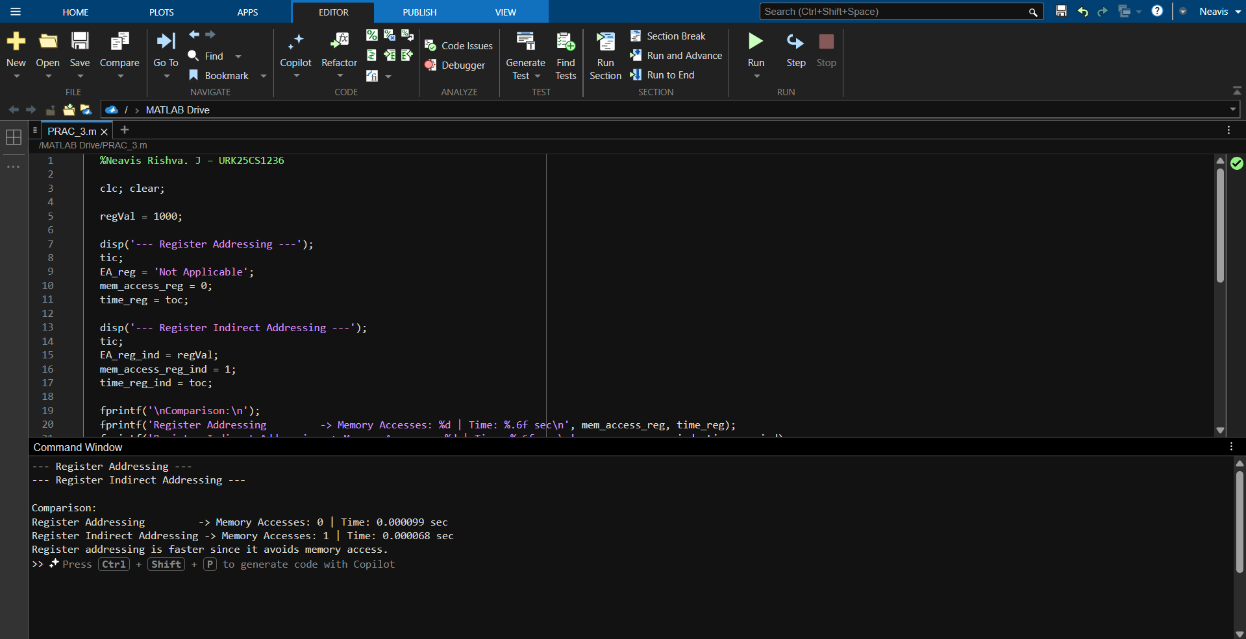

- Execute the program using Displacement addressing and Base + Index + Displacement addressing with the same base and offset values and analyze the effect of additional address computation on execution time.

CODE:

%Neavis Rishva. J – URK25CS1236

clc; clear;

base = 1000;
dispVal = 20;
index = 10;

disp('--- Displacement Addressing ---');
tic;
EA_disp = base + dispVal;
mem_access_disp = 1;
time_disp = toc;

disp('--- Base + Index + Displacement Addressing ---');
tic;
EA_bidxdisp = base + index + dispVal;
mem_access_bidxdisp = 1;
time_bidxdisp = toc;

fprintf('\nComparison:\n');
fprintf('Displacement Addressing -> EA: %d | Time: %.6f sec\n', EA_disp, time_disp);
fprintf('Base + Index + Displacement Address -> EA: %d | Time: %.6f sec\n', EA_bidxdisp, time_bidxdisp);

if time_disp < time_bidxdisp
disp('Displacement addressing is faster because it requires fewer arithmetic additions.');
end

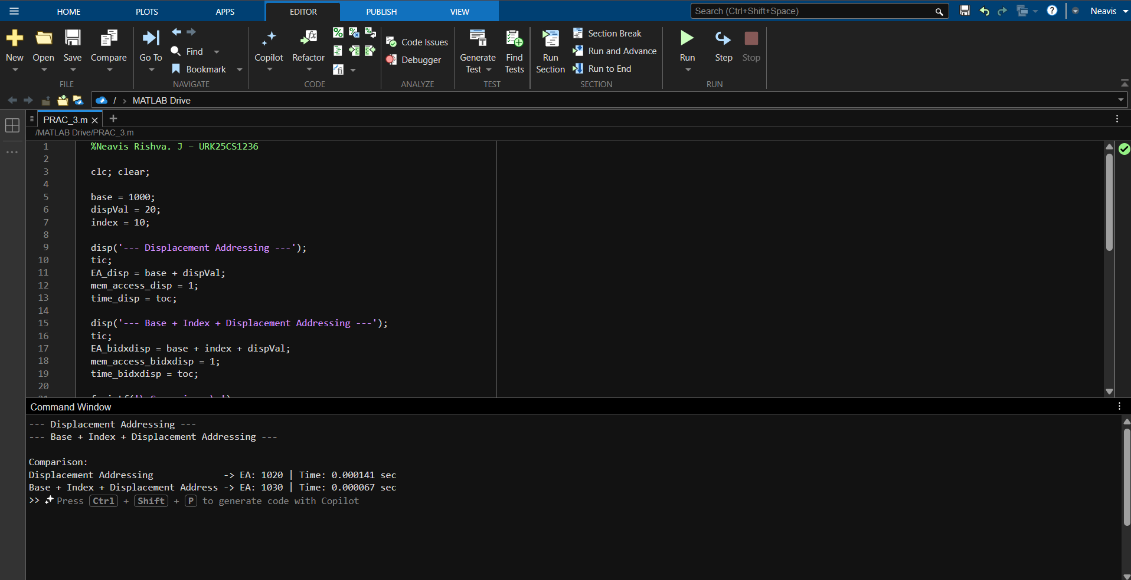

- Observations and Dimensional Measurement (To be filled by the students)

S. No. | Test Case ID | Instruction / Addressing Mode Selected | Input Values (Base / Index / Disp / PC / SP) | Effective Address (EA) | No. of Memory Accesses | Execution Time (tic/toc) | Execution Speed (Fast / Moderate / Slow) | Power Consumption (Less/More)
1 | TC-1 | Immediate Addressing | Operand = 25 | NA | 0 | 0.000012 | Fast | Less
2 | TC-2 | Indirect Addressing | Pointer = 1500 | 1500 | 2 | 0.000061 | Slow | More
3 | TC-3 | Indexed Addressing | Base = 1000, Index = 20 | 1020 | 1 | 0.000030 | Moderate | More
4 | TC-4 | PC-Relative Addressing | PC = 5000, Offset = -10 | 4990 | 1 | 0.000040 | Moderate | More
Note: Instructions for Filling the Table:
- Test Case ID:
Assign a unique ID for each run (TC–1, TC–2, etc.).
- Instruction / Addressing Mode Selected:
Mention the addressing mode chosen in the MATLAB program
(e.g., Direct, Indirect, Indexed, Displacement, Base+Index+Disp, PC-Relative, Stack).
- Input Values:
Enter the values provided by the user such as Base address, Index value, Displacement, PC, or SP depending on the addressing mode.
- Effective Address (EA):
Record the effective address calculated and displayed by the MATLAB program.
- No. of Memory Accesses:
Enter the number of memory accesses required for the selected addressing mode as shown by the program.
- Execution Time (tic/toc):
Record the execution time displayed by the MATLAB program (relative comparison).
- Execution Speed:
Mark Fast or Slow based on the number of memory accesses.
- Power Consumption:
Mark Less or More based on memory access involvement.

- Results/Observations

- Immediate and Register addressing modes required 0 memory accesses, resulting in the fastest execution time and lowest power consumption.
- Direct, Indexed, Displacement, PC-relative, and Stack addressing modes required 1 memory access, resulting in moderate execution time and moderate power consumption.
- Indirect addressing required 2 memory accesses, which resulted in slower execution speed and higher power consumption compared to other modes.
- The Effective Address (EA) was correctly computed according to the addressing mode formulas

- Interpretation of Results

- Addressing modes that do not access memory (Immediate and Register) are faster because operands are available within the instruction or CPU register itself. This reduces latency and power consumption.
- Addressing modes requiring one memory access show moderate performance because the processor must fetch data from memory once.
- Indirect addressing is slower because it requires two memory accesses — one to fetch the pointer and another to fetch the operand — increasing delay and energy usage.
- Complex address computation (Base + Index + Displacement) slightly increases execution time due to additional arithmetic operations, even though memory access count remains the same.

- Conclusions

- Immediate and Register addressing modes are most suitable for real-time systems due to zero memory access and faster execution.
- Indirect addressing is the slowest because it involves multiple memory accesses.
- Addressing modes like Indexed and Displacement are efficient for array and structured data access.
- PC-relative addressing is suitable for control flow and relocatable code.
- The experiment confirms that reducing memory access improves execution speed and lowers power consumption.

- Suggested Practicum Related Questions:

Note: Below are a few questions related to industry-specific higher-order thinking skills (HOT) that teachers must use to ensure students achieve the predetermined course outcomes.

- Justify how the number of memory accesses differs between Direct and Indirect addressing modes and explain its impact on execution speed and power consumption.
- Determine how Effective Address (EA) computation varies across Indexed, Displacement, and Base + Index + Displacement addressing modes using the MATLAB simulation results.
- Recommend a suitable addressing mode for real-time systems by analyzing memory access count and execution time obtained using tic and toc.
- Generate a comparative analysis using MATLAB outputs to show why Register or Immediate addressing modes provide better predictability than memory-based addressing modes.
- Justify why PC-relative addressing is preferred over Direct addressing in modern processors for control-flow instructions and relocatable code.
- References / Suggestions for further reading

- Computer Organization and Architecture – Instruction Set Architecture and Addressing Modes
- Processor Architecture Textbooks

- Suggested Assessment Scheme

The performance indicators given serve as a guideline for assessing the ‘process-related skills/LOs’ (marks to be awarded in real-time in the laboratory by the faculty member, as these cannot be measured after the practicum is over) and ‘product-related skills/LOs’

Note: The weightage for the process-related skills and product-related skills will change depending on the PrO, COs, and the competency related to the concerned course.

Performance Indicators |  | Maximum Marks | Marks Obtained
Process-related Skills: 18 Marks - 60%
1 | Correctly creating and running MATLAB scripts (coding hygiene, commenting, workspace handling). | 6
2 | Selecting appropriate arithmetic operations for the given data. | 5
3 | Following safety, coding ethics, and good laboratory practices (file management, backups). | 4
4 | Contribution as a team member (peer collaboration, sharing datasets, debugging). | 3
Product-related Skills: 12 Marks - 40%
1 | Producing accurate computation results and well-formatted MATLAB Table output. | 3
2 | Correct interpretation of logical comparisons. | 2
3 | Interpretation of results (clarity, mathematical validity). | 3
4 | Drawing meaningful conclusions using NEP-aligned verbs (justify, determine, generate). | 2
5 | Ability to answer practicum-related higher-order questions. | 1
6 | Submitting the report on time with screenshots and code | 1
Total |  | 30

To be filled by Student:

S.No. | Name of the Student | Register No.
1 | NEAVIS RISHVA. J | URK25CS1236

To be filled by the Faculty Member:
Marks Obtained |  |  | Name and Designation of the Faculty Member | Date of Evaluation
Process-Related Skills  (18) | Product-Related Skills (12) | Total  (30)

*******

